Tina Kellen Mathews, M.S., L.Ac.
Divine Right Acupuncture, P.C.


Initial intake form
(please note that all information is confidential!)

Date:

Patient Information

Name: Male/Female
Age: Date of Birth:
Home Address:

Home Phone: Cell: Work Phone:
Email:

Emergency Contact: Relationship to Patient:
Emergency Contact Phone number:
Primary Care Physician (PCP): PCP Phone:
Date of last medical examination:
Occupation:

- Experience with Acupuncture
- Have you received acupuncture treatment before? YES NO
- If yes, for what conditions and what was the outcome?

- Description of Major Complaints
  - In order of priority, what are your complaints?
- Complaint #1:
- Complaint #2:
  - COMPLAINT # 1:
Please answer the following questions focusing on Complaint # 1 ONLY:
    - Briefly explain history of Complaint #1, i.e. how long have you had this condition; was the onset SUDDEN or GRADUAL; was there a significant event that lead to this condition?

    - Have you seen a physician (or other primary care provider) for Complaint # 1? If yes, when and what diagnosis did you receive?

    - Other Care: what other therapies are you doing/ have you done to manage Complaint # 1, e.g. physical therapy, medication, chiropractic, etc.? Did these/ are these other therapies helping?

    - Rate the intensity of the PHYSICAL DISCOMFORT associated with Complaint # 1:
(None) 0 1 2 3 4 5 6 7 8 9 10 (Unbearable)

    - How EMOTIONALLY DISTRESSED are you by Complaint # 1?
(Not at all) 0 1 2 3 4 5 6 7 8 9 10 (Extremely)

    - How does Complaint # 1 interfere with your life, i.e. what activities are affected?

    - Are the symptoms of Complaint # 1 relieved by anything (e.g. heat, cold, pressure, movement, rest, etc.)?

    - Are the symptoms of Complaint # 1 worsened by anything (e.g. heat, cold, pressure, movement, rest, etc.)?

  - COMPLAINT # 2:
Please answer the following questions focusing on Complaint # 2 ONLY:
    - Briefly explain history of Complaint #2, i.e. how long have you had this condition; was the onset SUDDEN or GRADUAL; was there a significant event that lead to this condition?

    - Have you seen a physician (or other primary care provider) for Complaint # 2? If yes, when and what diagnosis did you receive?

    - Other Care: what other therapies are you doing/ have you done to manage Complaint # 2, e.g. physical therapy, medication, chiropractic, etc.? Did these/ are these other therapies helping?

    - Rate the intensity of the PHYSICAL DISCOMFORT associated with Complaint # 2:
(None) 0 1 2 3 4 5 6 7 8 9 10 (Unbearable)

    - How EMOTIONALLY DISTRESSED are you by Complaint # 2?
(Not at all) 0 1 2 3 4 5 6 7 8 9 10 (Extremely)

    - How does Complaint # 2 interfere with your life, i.e. what activities are affected?

    - Are the symptoms of Complaint # 2 relieved by anything (e.g. heat, cold, pressure, movement, rest, etc.)?

    - Are the symptoms of Complaint # 2 worsened by anything (e.g. heat, cold, pressure, movement, rest, etc.)?

(Not at all) 0 1 2 3 4 5 6 7 8 9 10 (Extremely)

  - On the diagram, please shade in the areas where you feel symptoms associated with your complaints. PLEASE NUMBER THE COMPLAINTS AS ABOVE (#1; #2; #3):
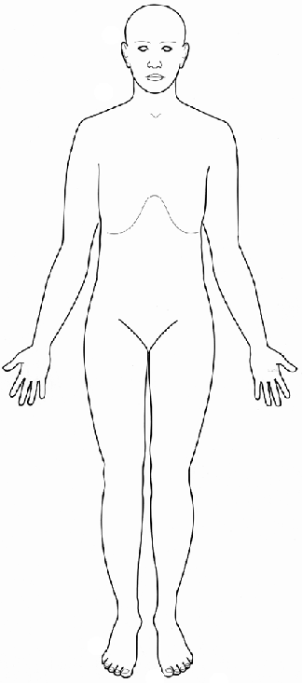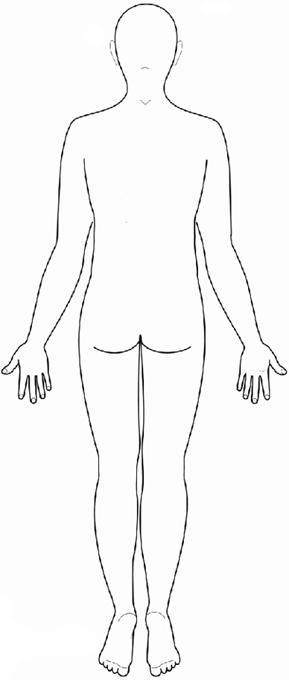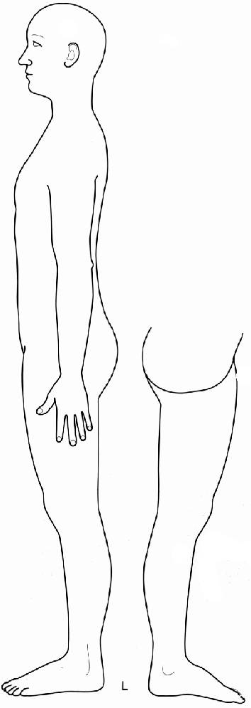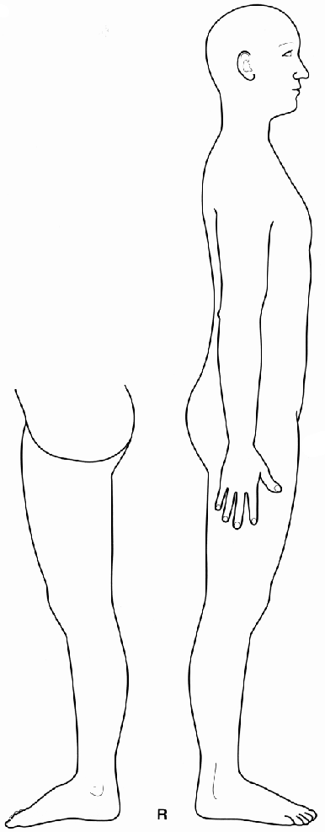
- Medications, Supplements and herbs
Please list all medications, (prescriptions and over-the-counter drugs) supplements and/or herbs you are CURRENTLY taking:

Medications, supplements, or herbs: Indication/For treatment of:
1. 1.
2. 2.
3. 3.
4. 4.
5. 5.
6. 6.
7. 7.
8. 8.
9. 9.
10. 10.

ALLERGIES (to medications, supplements, herbs):

  - Personal Medical History

    - Birth: Describe anything significant/traumatic about your birth:

    - Vaccination History: Any unusual reaction? Any unusual vaccination?

    - Childhood Illnesses (0-12 years): Any surgery, accidents & /or major illnesses? Please list in chronological order and indicate duration of illnesses.
Age:
    - Adolescence Illnesses (13-17 years): Any surgery, accidents & /or major illnesses? Please list in chronological order and indicate duration of illnesses.
Age:
    - Adulthood Illnesses (18 – 35 years): Any surgery, accidents & /or major illnesses? Please list in chronological order and indicate duration of illnesses.
Age:
Age:
    - Adulthood Illnesses (36 & up): Any surgery, accidents & /or major illnesses? Please list in chronological order and indicate duration of illnesses.
Age:
Age:
Age:
Age:

  - Family Medical History
Please note all major illnesses in your close family, e.g. diabetes, heart disease, hypertension, neurological disorders, psychological disorders, blood disorders, cancer, high cholesterol, etc.

Mother
Father
Siblings
Maternal Grandparents
Paternal Grandparents

  - Symptom Overview BY System
Please check all symptoms that you are CURRENTLY experiencing AND/OR experience FREQUENTLY.

Musculoskeletal
Joint clicking
Limitation of movement
Stiffness
Spasms or cramps
Swelling
Weakness
Pain: Full body
Pain: Facial (e.g. jaw)
Pain: Neck
Pain: Upper Back
Pain: Mid Back
Pain: Low Back
Pain: Shoulder
Pain: Elbow
Pain: Wrist
Pain: Hand
Pain: Hip
Pain: Knee
Pain: Ankle
Pain: Foot
OTHER (Please list)

Eyes, Ears, Nose & Throat
Loss of vision
Eye pain
Tearing or eye dryness
Eye discharge
Eye redness
Ear discharge
Ear itching
Ear pain &/or infections
Loss of hearing
Ringing or buzzing in ears
Problems with balance (vertigo)
Olfaction (sense of smell) impaired
Nose obstruction (stuffiness)
Nose bleeds
Sinus pain, pressure &/or infections
OTHER (Please list)

Respiratory
Chest pain &/or tightness
Bluish discoloration of skin
Cough
Coughing up blood (hemoptysis)
Shortness of breath (dypsnea)
Sore throat
Sputum production
Voice changes
Wheezing
OTHER (Please list)

Cardiovascular
Changes in skin temperature & color
Chest pain &/or pressure
Edema
Fainting (syncope)
Fatigue
Palpitations
Skin ulceration
Swelling of the ankles &/or legs
OTHER (Please list)

Digestive
Abdominal distention/bloating
Abdominal mass
Abdominal pain
Acid regurgitation &/or Heartburn
Alternating constipation/diarrhea
Rectal bleeding
Constipation
Diarrhea
Gas
Eating disorder
Indigestion
Jaundice (yellow tint to skin &/or eyes)
Nausea
Vomiting
OTHER (Please list))

Urogenital
Difficulty with urine flow
Incontinence
Painful urination (dysurea)
Rashes
Red urine
Urinary tract infection (UTI)
OTHER (Please list)

Neurological
Changes in consciousness
Confusion
Difficulty concentrating
Dizziness
Dysphasia (impaired ability to speak)
Gait disturbance
Headache
Numbness and/or tingling
Loss of consciousness
Paralysis
Post shingles pain
Problems coordinating movements
Severe forgetfulness
Tremor
Visual disturbance
Weakness
OTHER (Please list)

Integumentary (Skin)
Changes in hair
Changes in nails
Changes in skin color
Itching (pruritis)
Never sweat
Rash and/or skin lesion
Unusual sweating
Wounds that will NOT heal
OTHER (Please list)

Psychological
Feelings of grief
Feeling of sadness
Feeling fearful/anxious/nervous
Difficulty managing anger
Feeling manic
Feeling worried or overly pensive
Feelings of panic
Feeling overwhelmed
Extreme mood swings
Extreme lack of emotion
OTHER (Please list)

Sleep
Difficulty falling asleep
Dream disturbed sleep
Wake up & cannot fall back asleep
OTHER (Please list)

Miscellaneous
Extremely low energy/fatigue
OTHER (Please list)

FOR WOMEN ONLY

Abnormal vaginal bleeding
Changes in hair distribution
Fertility concerns
Irregular menstruation
Menopausal symptoms
No menses
Pain with menses (dysmenorrhea)
Pain during or after sexual relations
Pelvic pain
Premenstrual symptoms
Sexual dysfunction
Unusual discharge
OTHER (Please list)

Are you pregnant OR trying to become pregnant?
YES NO

Have you ever been pregnant? YES NO If yes, how many pregnancies:

# Births
# Miscarriages
# Abortions

FOR MEN ONLY

Fertility concerns
Prostate problems
Sexual dysfunction
Unusual discharge
OTHER (Please list)

VII. MEDICAL DISEASES/CONDITIONS. Please check all that apply AND indicate (by circling) if it is chronic or if you had the problem in the past, but is now resolved.
- C = Current condition
- P = Past condition, but is now resolved.

C P AIDS/HIV
C P Alcoholism &/or substance addiction
C P Allergies (If yes, pls indicate diagnosis & history)

C P Anemia
C P Asthma
C P Bell’s Palsy
C P Blood clotting disorder (If yes, pls indicate diagnosis & history)

C P Bipolar disorder
C P Cancer (If yes, pls indicate diagnosis &
history)

C P Chron’s Disease &/or colitis
C P Chronic Fatigue Syndrome (CFIDS)
C P Depression (Major)
C P Diabetes
C P Eczema
C P Endometriosis
C P Fibroids
C P Infertility
C P Lung disease, e.g. COPD (If yes, pls
indicate diagnosis & history)

C P Fibromyalgia
C P Gallstones
C P Heart disease (If yes, pls indicate diagnosis
& history)

C P Hepatitis A / B / C
C P Hernia
C P Herpes
C P Hypertension
C P Hypoglycemia
C P Irritable Bowel Syndrome (IBS)
C P Joint Replacement (If yes, pls indicate
diagnosis & history)

C P Kidney Stones and/or Disease (If yes, pls
indicate diagnosis & history)

C P Lupus
C P Lyme Disease
C P Lymph node removal
C P Mitral valve prolapse
C P Mood Disorder
C P Mononucleosus
C P Multiple Sclerosis
C P Organ removal or transplant (If yes, pls
indicate diagnosis & history)

C P Osteoarthritis
C P Osteoporosis
C P Pacemaker (heart or stomach)
C P Parkinson’s Disease
C P Pelvic Inflammatory Disease
C P Polio
C P Psoriasis
C P PTSD (Post-Traumatic Stress Disorder)
C P Reflux esophagistis (GERD)
C P Rheumatic fever
C P Rheumatoid arthritis
C P Scarlet Fever
C P Schizophrenia
C P Scoliosis
C P Seizures and /or epilepsy
C P Shingles
C P Sleep Disorder
C P Stroke
C P Schizophrenia
C P Thyroid disease (If yes, pls indicate
diagnosis & history)

C P Ulcer
C P Trigeminal Neuralgia
C P Tuberculosis
C P Vascular disease (e.g. phlebitis) (If yes,
Pls. indicate diagnosis & history)

C P OTHER (pls list)

  - Lifestyle Information

- Stress, Energy Level & Sleep

- What aspects of your life are most satisfying?

- Currently, what aspect/s of your life is most stressful? Are you undergoing any significant life changes?

- What are your coping strategies for stress management? List the activities that help you relax and indicate whether or not you are currently engaging in these activities:

- Do you believe that stress has an impact on your complaints? If yes, briefly describe to what extent you believe stress plays a role in worsening symptoms:
- Complaint #1:
- Complaint #2:

- Briefly describe your energy level (e.g. excellent, easily fatigued, up & down etc.). Are you satisfied with your energy level?

- Is your energy level affected by your complaints? If yes, please briefly describe:
- Complaint #1:
- Complaint #2:

- Describe your sleep habits and sleep quality (e.g. pain interferes with sleep; careful to get at least 8 hours of sleep/night; difficulty falling asleep; wake frequently to urinate; wake frequently & cannot fall back to sleep; dream disturbed sleep; etc.)

- Rate your sexual drive: STRONG MODERATE LOW NONE

- Smoking, Alcohol & Drugs

      - Do you smoke tobacco? YES NO If yes, please describe amount and frequency of use. What impact do you believe smoking has on your complaints?

      - Do you drink alcohol? YES NO If yes, please describe how much and under what circumstances you drink. What impact do you believe alcohol consumption has on your complaints?

      - Do you use recreational drugs and/or prescription medications that your physician does not know about? YES/ NO What impact do you believe this has on your complaints?

- Diet and Nutrition

      - Briefly describe your eating habits and appetite, including any dietary restrictions or diet regimen.

      - Do you believe that your diet has any impact on your complaints? YES/NO If yes, briefly describe:

- Complaint #1:
- Complaint #2:

      - Describe any food intolerances or allergies:

      - Are you concerned about your weight (under or overweight)? YES/NO If yes, briefly describe your concerns:

- Family & Social Support Systems

Do you have the support of a significant other, friends and/or family? If yes, please describe:

Are you in a long-term and/or serious relationship? YES/NO If yes, how do you feel about your relationship?

Do you live alone or with others (incl. pets)? Please describe:

Do you participate in any social and/or faith-based activities?

What aspects of your work (including homemaking) do you find rewarding (financial, social, meaningful, challenging, etc.)

Do you have any hobbies, special interests, and/or do you play sports? If yes, briefly describe:

  - Your Personal Goals for Treatment-Please describe your goals, hopes and expectations for your acupuncture treatments with Divine Right Acupuncture, P.C..

